Project Development Phase

Functional & Performance Testing – GenAI Template
Script-Controlled ACL – Restrict Record Access Based on Field Value
Date | 1 October 2026
Team ID | SWTID-2026-7653
Project Name | Script-Controlled ACL – Restrict Record Access Based on Field Value
Maximum Marks | 10 Marks

1. Applicability statement
The supplied GenAI template is adapted to a non-generative ServiceNow security workflow. Functional testing verifies correct ACL decisions; performance testing verifies latency and stability. No model-generated content or API key is involved.

2. Test Scenarios & Results
Test Case ID | Scenario | Test Steps | Expected Result | Actual Result | Pass/Fail
FT-01 | Valid Branch record | Create EEE/ECE/CSE sample records and open list | Records save and display according to ACL policy | Not Executed | Pending
FT-02 | READ authorization | Impersonate bb1 user and open list | EEE visible; non-EEE protected | Documented in source; confirm | Pass*
FT-03 | CRUD role ladder | Add bb2, bb3, bb4 progressively | Create, write, delete appear only at intended step | Documented in source; confirm | Pass*
FT-04 | Admin bypass | Open list as admin | All branches accessible | Documented in source; confirm | Pass*
PT-01 | Response time | Repeat reads at 100/1k/10k records | p95 within agreed threshold | Not measured | Not Executed
PT-02 | Concurrent requests | Run 1/10/25/50 users mixed workload | No unacceptable errors/timeouts | Not measured | Not Executed
PT-03 | Soak test | Run steady load for 30 minutes | No progressive degradation | Not measured | Not Executed

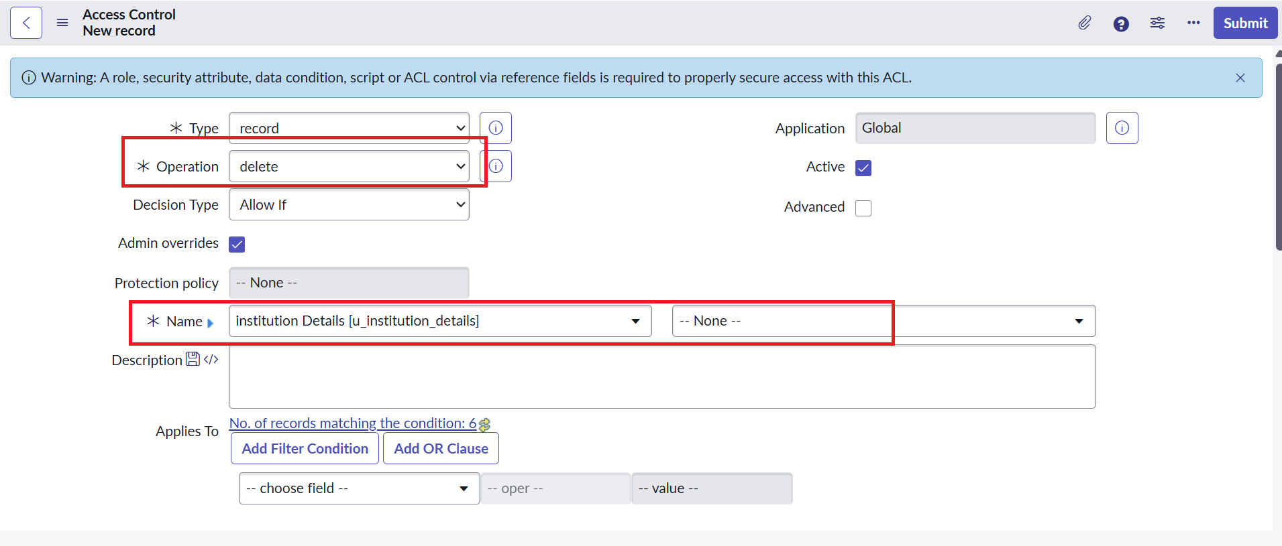
Project evidence: ACL operation configuration.

